Design Patterns Identified
Package java/org/jabref/preferences/

Creational Pattern
Builder pattern:
Located: java/org/jabref/preferences/PreviewPreferences.java

Allows you to construct different previews step by step using the same construction code.
Director (lines 10-67):
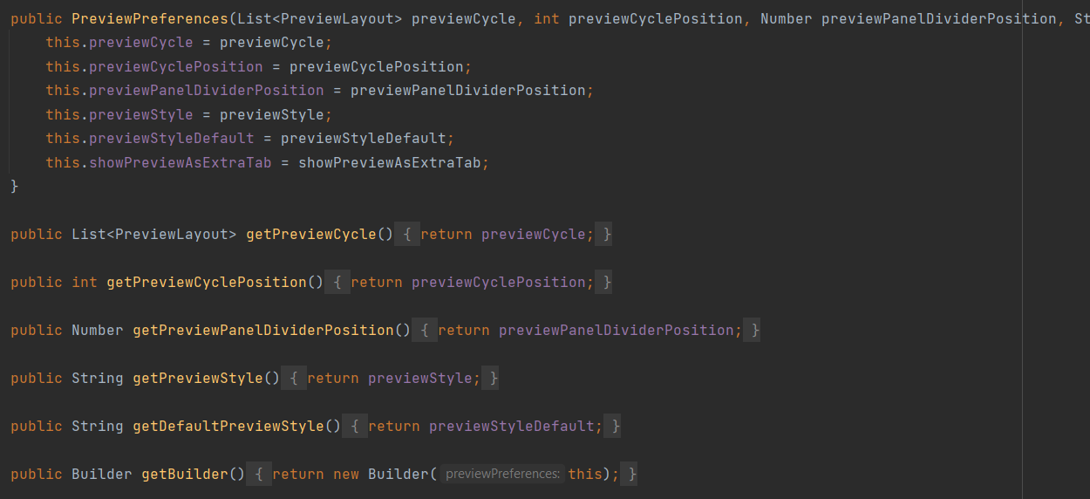
Builder (lines 71-124):
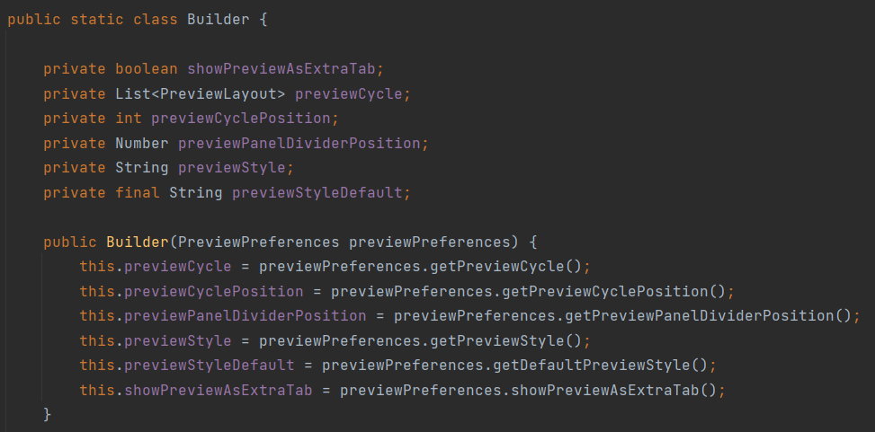

Singleton pattern:
Located: java/org/jabref/preferences/JabRefPreferences.java lines: 444-723

Ensures that JabRefPreferences has only one instance, while providing a global access point to this instance. The constructor of this class is private to ensure only one instance of this class is created.

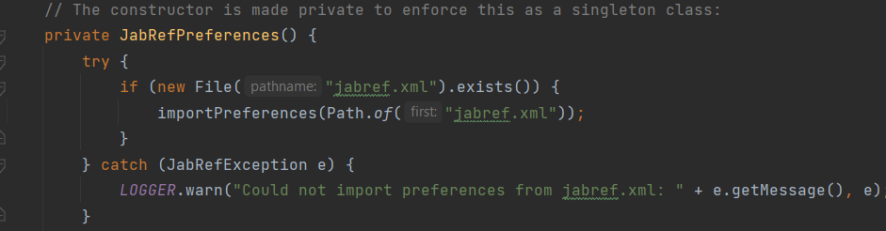
Facade pattern:
Located: java/org/jabref/preferences/JabRefPreferences.java

Every preference needs to go throw JabRefPreferences which provides convenient access to a particular part of the sub preference’s funtionality. It knows where to direct the client’s request and how to operate. For instance, if you want to get the Proxy Preferences, first you have to access the JabRefPreferences and create the proxyPreference’s object if not created with the correct current user information.
